Project 1

### <Dungeons and Dragons Combat Sim>

**CIS-5, Winter 2021**

**Name: Jason Wilmot**

**2/7/2021**

# Introduction

## Title: Dungeons and Dragons Combat Sim

Dungeons and Dragons (D&D) is a popular tabletop roleplaying game where players use dice rolls modified by character attributes to determine their success at any given task. In combat, a player will roll a twenty-sided die (commonly called a d20) modified by their character’s physical attributes and proficiency to see if they land a hit. Then, roll a smaller die with anywhere between twelve and four sides to find out how much damage was afflicted to their target.

A combat scenario may look like this…

*LVL 3 Fighter V.S. Goblin*

*Fighter rolls d20 + strength mod + proficiency mod to hit, resulting in 10 + 3 + 2 = 15*

*15 is greater than or equal to the Goblin’s Armor Class (AC) resulting in a hit.*

*Fighter rolls d8 + 3, resulting in 6 + 3 = 9 damage to the Goblin.*

*Fighter kills Goblin.*

My program provides general dice rolls, character stat generation, combat rolls VS user input, and auto combat simulation VS monsters.

# Summary

Project size: 516 lines  
Number of variables: ~35, not all unique  
Number of functions: 17

My project uses all the concepts we have learned from the book, and I hope to further modularize my code and add more aspects from D&D in project 2.

It took about 4 days to complete. Ever since the project was brought up in class, I was thinking of doing a D&D game, so I had most of the program planned out well in advance of starting it.  
My program barely scratches the surface of the complexity of D&D but choosing such a complex game gave me the opportunity to add different sections that show off what I’ve learned in class in creative ways.

# Description

The main point of this program is to serve as a hub filled with player resources that are commonly used during a game of D&D. These include dice rolls, combat rolls, and character creation.

# Flow Chart

# Pseudo Code

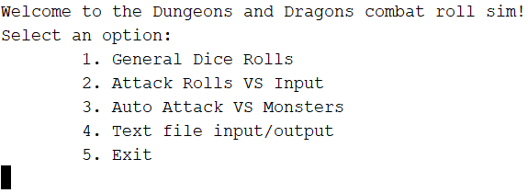//Personal info  
//Libraries  
//Function Prototypes  
 //Menu Functions  
 //Combat score functions  
 //Dice functions



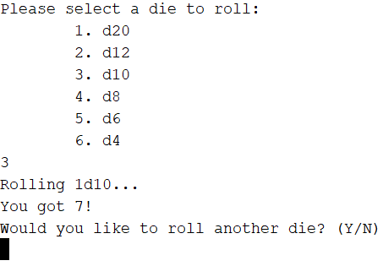//Main  
 //Start Seed  
 //Start home Menu function



//Home Menu  
 //Give player options  
 //Map options to menu functions  
 //Re-do if invalid option



//Dice Menu  
 //Give player dice options  
 //Map options to dice functions  
 //Re-do if invalid option  
 //Ask player if they want to roll again



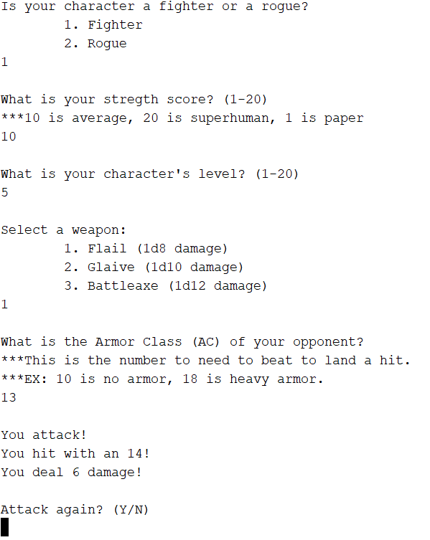//Attack VS Input Menu  
 //Declare variables  
 //Ask player for character class  
 //Ask for physical input based on class  
 //Check score validity  
 //Check class validity  
 //Character level input  
 //Validate level input  
 //Offer weapon options based on class  
 //Validate input  
 //AC Input  
 //Validate input  
 //Process attack using combat score functions  
 //Display hit or miss and combat values  
 //Ask player if they want to roll again



//Auto Attack VS Monster  
 //Declare variables  
 //Ask player for character class  
 //Ask for physical input based on class  
 //Check score validity  
 //Check class validity  
 //Character level input  
 //Validate level input  
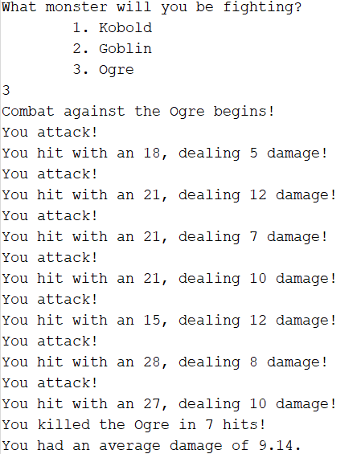 //Offer weapon options based on class  
 //Validate input   
 //Offer monster combat options  
 //Input monster stats into combat function  
 //Process attacks until monster is dead  
 //Display hit or miss and combat values  
 //Display how many hits it took to kill the monster   
 and average damage



//Text input/output Menu  
 //Give user input/output options  
 //Validate user input  
 //Go to input/output function based on choice

//Text output function  
 //Prompt user for a character name  
 //Generate random stats and age for   
 the character in text file



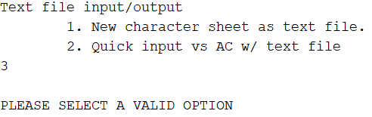//Text input function  
 //Prompt user to create file  
 //Ensure that file is created  
 //Prompt user for opponent AC  
 //Input file info and AC into combat function  
 //Process attack using functions  
 //Display results  
 //Ask player if they want to attack again



//Character stat processing functions  
 //Turn user inputs into attack modifiers or dice rolls



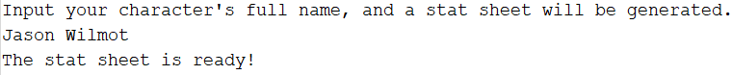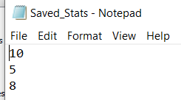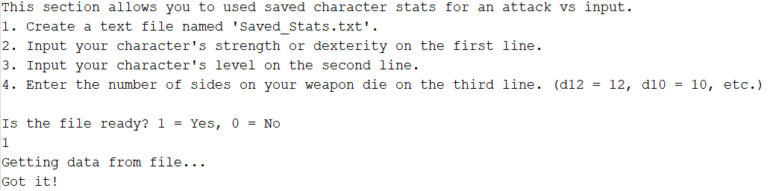 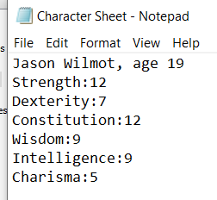//Dice functions   
 //Returns a random value within the dice range



# Program

/*

* File: main.cpp

* Author: Jason Wilmot

* Created on Febuary 7, 2021

* Purpose: PROJECT FINAL

*/

//Libraries

#include <iostream> //I/O Library

#include <cstdlib> //Random Number Gererator

#include <ctime> //Time to set the seed

#include <iomanip>

#include <fstream>

#include <string>

#include <cmath>

using namespace std;

//Function Prototypes

//Menu functions

void hMenu(); //Home Menu

void dMenu(); //General Dice roll menu

void aviMenu(); //Attack vs Input menu

void avmMenu(); //Attack vs Monster menu

void txtMenu(); //Text file export/import menu

void txtInput(); //Text file input

void txtOutput(); //Text file output

//Combat score functions

short int aMod(unsigned short int aScore); //Converts an ability score to an ability modifyer

unsigned short int proMod(unsigned short int level); //Uses level to get proficiency mod

unsigned short int wpnDmg(unsigned short int wpnDie); //Weapon damage based on die type

//Dice functions

unsigned short int d20(); //d20 dice roll

unsigned short int d12(); //d12 dice roll

unsigned short int d10(); //d10 dice roll

unsigned short int d8(); //d8 dice roll

unsigned short int d6(); //d6 dice roll

unsigned short int d4(); //d4 dice roll

int main(int argc, char** argv) { //Start seed and start home menu function

//Initialize the Random Number Seed

srand(static_cast<unsigned int>(time(0)));

//Output data

hMenu();

return 0;

}

void hMenu(){ //Home Menu

unsigned short int menu1;

while (menu1 > 5 || menu1 < 1) {

cout << "Welcome to the Dungeons and Dragons combat roll sim!" << endl;

cout << "Select an option:" << endl;

cout << "\t1. General Dice Rolls" << endl;

cout << "\t2. Attack Rolls VS Input" << endl;

cout << "\t3. Auto Attack VS Monsters" << endl;

cout << "\t4. Text file input/output" << endl;

cout << "\t5. Exit" << endl;

cin >> menu1;

switch(menu1){ //Outputs

case 1: dMenu(); break;

case 2: aviMenu(); break;

case 3: avmMenu(); break;

case 4: txtMenu(); break;

case 5: break;

}

if (menu1 > 5 || menu1 < 1) //Re-do if invalid option

cout << endl << "PLEASE SELECT A VALID OPTION" << endl;

}

}

void dMenu(){ //Dice Menu

unsigned short int menu1;

char menu2;

do{

while (menu1 > 6 || menu1 < 1) {

cout << "Please select a die to roll:" <<endl;

cout << "\t1. d20" << endl;

cout << "\t2. d12" << endl;

cout << "\t3. d10" << endl;

cout << "\t4. d8" << endl;

cout << "\t5. d6" << endl;

cout << "\t6. d4" << endl;

cin >> menu1;

switch(menu1){ //Outputs

case 1: cout << "Rolling 1d20... \nYou got " << d20() << "!"; break;

case 2: cout << "Rolling 1d12... \nYou got " << d12() << "!"; break;

case 3: cout << "Rolling 1d10... \nYou got " << d10() << "!"; break;

case 4: cout << "Rolling 1d8... \nYou got " << d8() << "!"; break;

case 5: cout << "Rolling 1d6... \nYou got " << d6() << "!"; break;

case 6: cout << "Rolling 1d4... \nYou got " << d4() << "!"; break;

}

if (menu1 > 6 || menu1 < 1) //Re-do if invalid option

cout << endl << "PLEASE SELECT A VALID OPTION" << endl;

}

cout << endl << "Would you like to roll another die? (Y/N)" << endl; //Ask if player wants to roll again

menu1 = 0;

cin >> menu2;

} while (menu2 == 'Y' || menu2 == 'y');

}

void aviMenu(){ //Attack VS Input

//Declare Variables

unsigned short int Class; //Class, 1 is figher, 2 is rogue.

unsigned short int aScore; //Ability score, used in attack rolls.

unsigned short int level; //Character level

unsigned short int AC; //Armor Class

short int toHit; //The "To Hit" value used to determine if a character lands an attack.

unsigned short int wpnMenu; //Used for selecting an option in the weapons menu.

unsigned short int wpnDie; //Serves as an input for the wpnDmg function

char again; //Tests if the user wants to attack again.

short int dmg; //Damage

//Initialize Variables

do { //Class & ability score checker

cout << endl << "Is your character a fighter or a rogue?" << endl;

cout << "\t1. Fighter" << endl;

cout << "\t2. Rogue" << endl;

cin >> Class;

if (Class == 1) { //Strength input for fighters

do {

cout << endl << "What is your stregth score? (1-20)" << endl;

cout << "***10 is average, 20 is superhuman, 1 is paper" << endl;

cin >> aScore;

if (aScore > 20 || aScore < 1) //Str score validity check

cout << endl << "PLEASE INPUT A VALID NUMBER" << endl;

} while (aScore > 20 || aScore < 1);

}

else if (Class == 2){ //Dexterity input for rigues

do {

cout << endl << "What is your dexterity score? (1-20)" << endl;

cout << "***10 is average, 20 is superhuman, 1 a rock" << endl;

cin >> aScore;

if (aScore > 20 || aScore < 1) //Dex score validity check

cout << endl << "PLEASE INPUT A VALID NUMBER" << endl;

} while (aScore > 20 || aScore < 1);

}

else //Class validity check

cout << endl << "PLEASE SELECT A VALID OPTION" << endl;

} while (Class < 1 || Class > 2);

do { //Character level input

cout << endl << "What is your character's level? (1-20)" << endl;

cin >> level;

if (level > 20 || level < 1) //Level input check

cout << endl << "PLEASE INPUT A VALID NUMBER" << endl;

} while (level > 20 || level < 1);

if (Class == 1) { //Fighter weapon options

do {

cout << endl << "Select a weapon:" << endl;

cout << "\t1. Flail (1d8 damage)" << endl;

cout << "\t2. Glaive (1d10 damage)" << endl;

cout << "\t3. Battleaxe (1d12 damage)" << endl;

cin >> wpnMenu;

switch (wpnMenu){

case 1: wpnDie = 8; break;

case 2: wpnDie = 10; break;

case 3: wpnDie = 12; break;

}

if (wpnMenu > 3 || wpnMenu < 1) //Validity check

cout << endl << "PLEASE SELECT A VALID OPTION" << endl;

} while (wpnMenu > 3 || wpnMenu < 1);

}

else { //Rogue weapon options

do {

cout << endl << "Select a weapon:" << endl;

cout << "\t1. Dagger (1d4 damage)" << endl;

cout << "\t2. Shortbow (1d6 damage)" << endl;

cout << "\t3. Rapier (1d8 damage)" << endl;

cin >> wpnMenu;

switch (wpnMenu){

case 1: wpnDie = 4; break;

case 2: wpnDie = 6; break;

case 3: wpnDie = 8; break;

}

if (wpnMenu > 3 || wpnMenu < 1) //Validity check

cout << endl << "PLEASE SELECT A VALID OPTION" << endl;

} while (wpnMenu > 3 || wpnMenu < 1);

}

do { //AC input

cout << endl << "What is the Armor Class (AC) of your opponent?" << endl;

cout << "***This is the number to need to beat to land a hit." << endl;

cout << "***EX: 10 is no armor, 18 is heavy armor." << endl;

cin >> AC;

if (AC > 26) //Validity check

cout << "That'll be a bit too hard to hit, try a lower number." <<endl;

} while (AC > 26);

do { //Attack!

cout << endl << "You attack!" << endl;

toHit = d20() + aMod(aScore) + proMod(level);

if (toHit >= AC){ //Hit or Miss

cout << "You hit with an " << toHit << "!" << endl;

dmg = wpnDmg(wpnDie) + aMod(aScore);

if (dmg < 1)

dmg = 1;

cout << "You deal " << dmg << " damage!" << endl;

}

else

cout << "You missed with an " << toHit << "..." << endl;

cout << endl << "Attack again? (Y/N)"<< endl; //Again?

cin >> again;

} while (again == 'Y' || again == 'y');

}

void avmMenu(){ //Attack VS Monster

unsigned short int Class; //Class, 1 is figher, 2 is rogue.

unsigned short int aScore; //Ability score, used in attack rolls.

unsigned short int level; //Character level

unsigned short int AC; //Armor Class

short int toHit; //The "To Hit" value used to determine if a character lands an attack.

unsigned short int wpnMenu; //Used for selecting an option in the weapons menu.

unsigned short int monMenu; //Used to navigate the monster menu.

unsigned short int wpnDie; //Serves as an input for the wpnDmg function

char again; //Tests if the user wants to attack again.

float avrgDmg; //Average damage

short int HP; //Hit points

short int dmg; //Damage

float ttlDmg; //Total damage

string monName; //Monster name

//Initialize Variables

do { //Class & ability score checker

cout << endl << "Is your character a fighter or a rogue?" << endl;

cout << "\t1. Fighter" << endl;

cout << "\t2. Rogue" << endl;

cin >> Class;

if (Class == 1) { //Strength input for fighters

do {

cout << endl << "What is your stregth score? (1-20)" << endl;

cout << "***10 is average, 20 is superhuman, 1 is paper" << endl;

cin >> aScore;

if (aScore > 20 || aScore < 1) //Str score validity check

cout << endl << "PLEASE INPUT A VALID NUMBER" << endl;

} while (aScore > 20 || aScore < 1);

}

else if (Class == 2){ //Dexterity input for rigues

do {

cout << endl << "What is your dexterity score? (1-20)" << endl;

cout << "***10 is average, 20 is superhuman, 1 a rock" << endl;

cin >> aScore;

if (aScore > 20 || aScore < 1) //Dex score validity check

cout << endl << "PLEASE INPUT A VALID NUMBER" << endl;

} while (aScore > 20 || aScore < 1);

}

else //Class validity check

cout << endl << "PLEASE SELECT A VALID OPTION" << endl;

} while (Class < 1 || Class > 2);

do { //Character level input

cout << endl << "What is your character's level? (1-20)" << endl;

cin >> level;

if (level > 20 || level < 1) //Level input check

cout << endl << "PLEASE INPUT A VALID NUMBER" << endl;

} while (level > 20 || level < 1);

if (Class == 1) { //Fighter weapon options

do {

cout << endl << "Select a weapon:" << endl;

cout << "\t1. Flail (1d8 damage)" << endl;

cout << "\t2. Glaive (1d10 damage)" << endl;

cout << "\t3. Battleaxe (1d12 damage)" << endl;

cin >> wpnMenu;

switch (wpnMenu){

case 1: wpnDie = 8; break;

case 2: wpnDie = 10; break;

case 3: wpnDie = 12; break;

}

if (wpnMenu > 3 || wpnMenu < 1) //Validity check

cout << endl << "PLEASE SELECT A VALID OPTION" << endl;

} while (wpnMenu > 3 || wpnMenu < 1);

}

else { //Rogue weapon options

do {

cout << endl << "Select a weapon:" << endl;

cout << "\t1. Dagger (1d4 damage)" << endl;

cout << "\t2. Shortbow (1d6 damage)" << endl;

cout << "\t3. Rapier (1d8 damage)" << endl;

cin >> wpnMenu;

switch (wpnMenu){

case 1: wpnDie = 4; break;

case 2: wpnDie = 6; break;

case 3: wpnDie = 8; break;

}

if (wpnMenu > 3 || wpnMenu < 1) //Validity check

cout << endl << "PLEASE SELECT A VALID OPTION" << endl;

} while (wpnMenu > 3 || wpnMenu < 1);

}

do { //Monster selection

cout << endl << "What monster will you be fighting?" << endl;

cout << "\t1. Kobold" << endl; //Add monsters

cout << "\t2. Goblin" << endl;

cout << "\t3. Ogre" << endl;

cin >> monMenu;

switch (monMenu){ //set name, HP, and AC based on monster

case 1: monName = "Kobold"; HP = 5; AC = 12; break;

case 2: monName = "Goblin"; HP = 7; AC = 15; break;

case 3: monName = "Ogre"; HP = 59; AC = 11; break;

}

if (monMenu > 3 || monMenu < 1) //Validity check

cout << "PLEASE SELECT A VALID OPTION" << endl;

} while (monMenu > 3 || monMenu < 1);

cout << "Combat against the " << monName << " begins!" << endl;

int n;

ttlDmg = 0;

for (n = 0; HP > 0; n++){ //Attack!

cout << "You attack!" << endl;

toHit = d20() + aMod(aScore) + proMod(level);

if (toHit >= AC){ //Hit or Miss

cout << "You hit with an " << toHit;

dmg = wpnDmg(wpnDie) + aMod(aScore);

if (dmg < 1)

dmg = 1;

cout << ", dealing " << dmg << " damage!" << endl;

}

else {

dmg = 0;

cout << "You missed with an " << toHit << "..." << endl;

}

HP = HP - dmg;

ttlDmg = ttlDmg + dmg;

}

avrgDmg = (ttlDmg/n);

cout << "You killed the " << monName << " in " << n << " hits!" << endl;

cout << "You had an average damage of " << fixed << showpoint << setprecision(2) << avrgDmg << "." << endl;

}

void txtMenu(){ //File input/output menu

char menu1;

do {

cout << endl << "Text file input/output" << endl;

cout << "\t1. New character sheet as text file." << endl;

cout << "\t2. Quick input vs AC w/ text file" << endl;

cin >> menu1;

if (menu1 > '2' || menu1 < '1')

cout << endl << "PLEASE SELECT A VALID OPTION" << endl;

} while (menu1 > '2' || menu1 < '1');

switch (static_cast<int>(menu1)){

case 49: txtOutput(); break;

case 50: txtInput(); break;

}

}

void txtOutput() { //Function outputing a text file

//Variables

string name; //Character name

//File set up

ofstream outputFile;

outputFile.open("Character Sheet.txt");

cout << "Input your character's full name, and a stat sheet will be generated." << endl;

cin.ignore();

getline(cin, name);

//File outputs

outputFile << name << ", age " << 15 + pow(d6(), 2) << endl;

outputFile << "Strength:" << d6() + d6() + d6() << endl;

outputFile << "Dexterity:" << d6() + d6() + d6() << endl;

outputFile << "Constitution:" << d6() + d6() + d6() << endl;

outputFile << "Wisdom:" << d6() + d6() + d6() << endl;

outputFile << "Intelligence:" << d6() + d6() + d6() << endl;

outputFile << "Charisma:" << d6() + d6() +d6() << endl;

//Completion notice

cout << "The stat sheet is ready!" << endl;

//close file

outputFile.close();

}

void txtInput() { //Fuction using text file inputs

//Variables

unsigned short int aScore; //ability score

unsigned short int level; //character level

unsigned short int wpnDie; //weapon die

short int toHit;

bool ready; //ready to continue

unsigned short int AC;

char again;

//Prompt user to create file

cout << "This section allows you to used saved character stats for an attack vs input." << endl;

cout << "1. Create a text file named 'Saved_Stats.txt'." << endl;

cout << "2. Input your character's strength or dexterity on the first line." << endl;

cout << "3. Input your character's level on the second line." << endl;

cout << "4. Enter the number of sides on your weapon die on the third line. (d12 = 12, d10 = 10, etc.)" << endl;

cout << endl << "Is the file ready? 1 = Yes, 0 = No" << endl;

do {

cin >> ready;

if (ready != 1)

cout << "It's ok, take your time." << endl;

} while (ready != 1);

//File set up

ifstream inputFile;

inputFile.open("Saved_Stats.txt");

cout << "Getting data from file..." << endl;

//File inputs

inputFile >> aScore;

inputFile >> level;

inputFile >> wpnDie;

inputFile.close();

cout << "Got it!" << endl;

do { //AC input

cout << endl << "What is the Armor Class (AC) of your opponent?" << endl;

cout << "***This is the number to need to beat to land a hit." << endl;

cout << "***EX: 10 is no armor, 18 is heavy armor." << endl;

cin >> AC;

if (AC > 26) //Validity check

cout << "That'll be a bit too hard to hit, try a lower number." <<endl;

} while (AC > 26);

do { //Attack!

cout << "You attack!" << endl;

toHit = d20() + aMod(aScore) + proMod(level);

if (toHit >= AC){ //Hit or Miss

cout << endl << "You hit with an " << toHit << "!" << endl;

cout << "You deal " << wpnDmg(wpnDie) + aMod(aScore) << " damage!" << endl;

}

else

cout << "You missed with an " << toHit << "..." << endl;

cout << endl << "Attack again? (Y/N)"<< endl; //Again?

cin >> again;

} while (again == 'Y' || again == 'y');

}

short int aMod(unsigned short int aScore){ //Convert ability score into ability mod

return ((aScore/2) - 5);

}

unsigned short int proMod(unsigned short int level){ //Convert level into proficiency mod

return (((level - 1)/4)+2);

}

unsigned short int wpnDmg(unsigned short int wpnDie){ //Converts die type into damage

switch (wpnDie) {

case 12: return d12();

case 10: return d10();

case 8: return d8();

case 6: return d6();

case 4: return d4();

}

}

unsigned short int d20(){ //Rolls a 20 sided die

unsigned short int d20;

d20=rand()%20+1; //[1,20]

return d20;

}

unsigned short int d12(){ //Rolls a 12 sided die

unsigned short int d12;

d12=rand()%12+1; //[1,12]

return d12;

}

unsigned short int d10(){ //Rolls a 10 sided die

unsigned short int d10;

d10=rand()%10+1; //[1,10]

return d10;

}

unsigned short int d8(){ //Rolls an 8 sided die

unsigned short int d8;

d8=rand()%8+1; //[1,8]

return d8;

}

unsigned short int d6(){ //Rolls a 6 sided die

unsigned short int d6;

d6=rand()%6+1; //[1,6]

return d6;

}

unsigned short int d4(){ //Rolls a 4 sided die

unsigned short int d4;

d4=rand()%4+1; //[1,4]

return d4;

}